- unmount /mnt/loop2p1
- unmount /mnt/loop2p2
- unmount /mnt/loop2p3
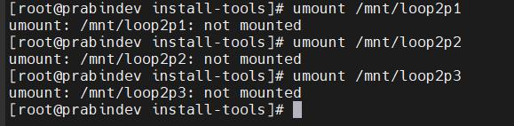
- kpartx -d /dev/loop2
- losetup -d /dev/loop2
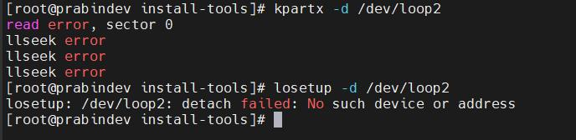
- ldd /root/software/exports/lin-vfr-x86_64-r/encrypt-vkr
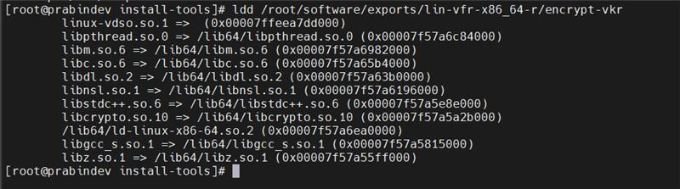
- mktemp -d /tmp/monolith.XXXXXXXX

8) cat /root/software/swv/platoform/atomic-dog/image/lin-nv40b-x86_64-r/monolith-nv40b-x86_64.jar | (cd /tmp; jarxx)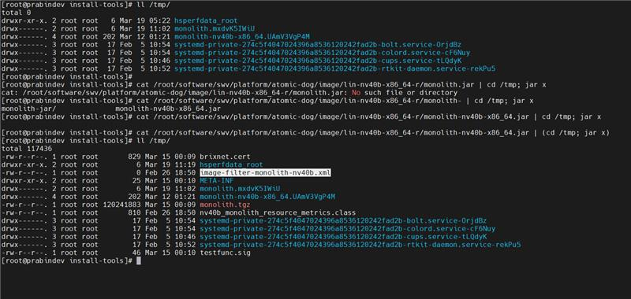
9) mkdir /tmp/monolith
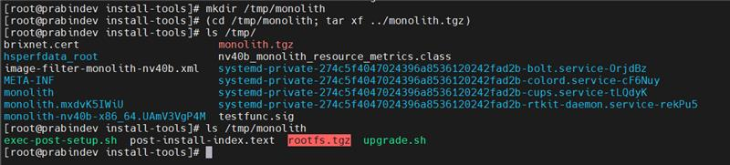

10) (cd /tmp/monolith; tar xf ../monolith.tgz)

11) mkdir /tmp/monolith.rootfs
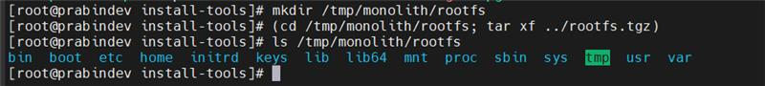

12) (cd /tmp/monolith/rootfs; tar xf ../rootfs.tgz)
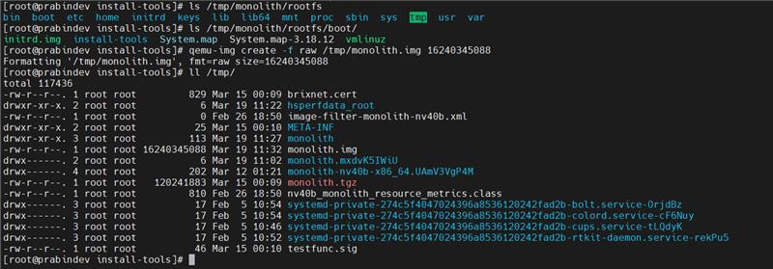
13) qemu -img create -f raw /tmp/monolith.img 16240345088

14) losetup /dev/loop /tmp/monolith.img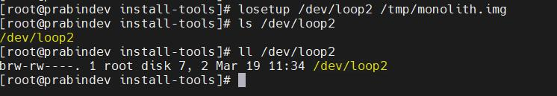
15) fdisk -H 64 -S 32 -u=cylinders /dev/loop2
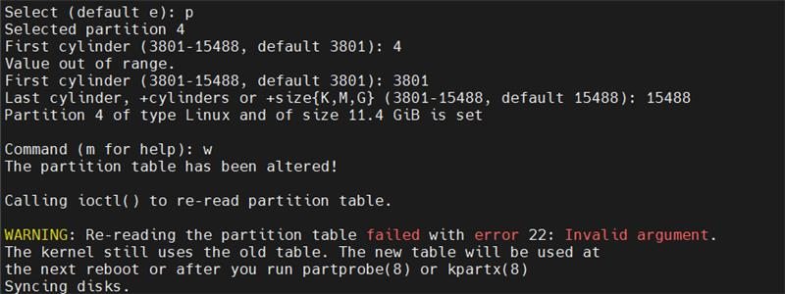
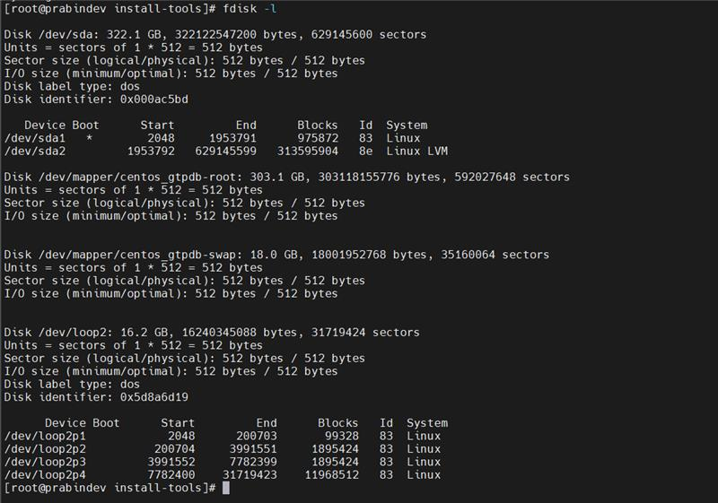
16) kpartx -a -v /dev/loop2
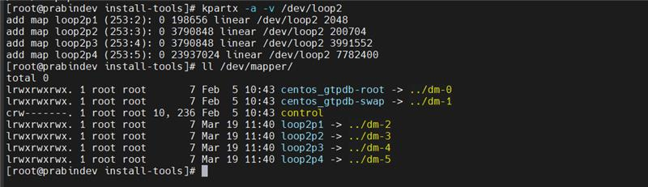

17) mke2fs -j -L bootfs /dev/mapper/loop2p1
18) tune2fs -c 0 -i 0 /dev/mapper/loop2p1
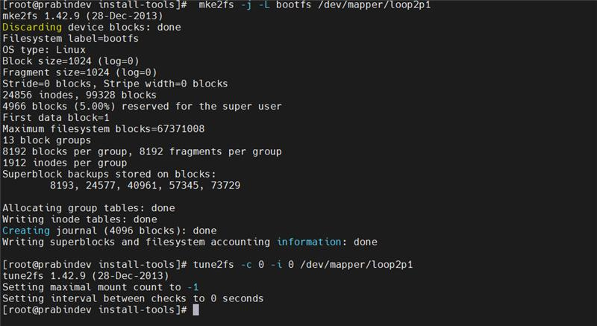
19) mke2fs -j -L bootfs /dev/mapper/loop2p2
20) tune2fs -c 0 -i 0 /dev/mapper/loop2p2
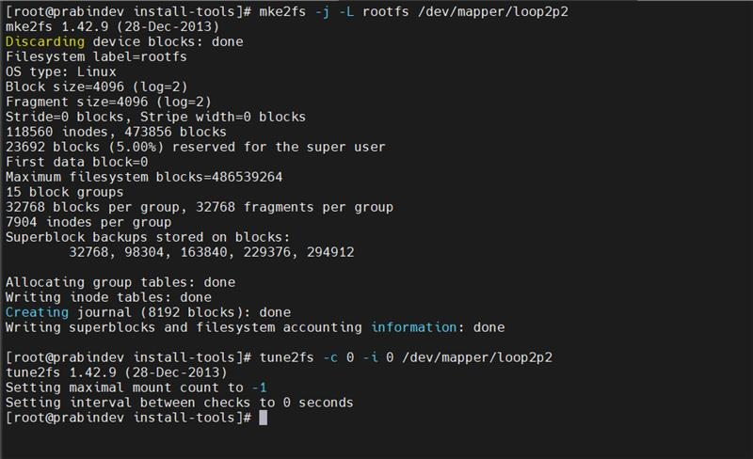
21) mke2fs -j -L bootfs /dev/mapper/loop2p3
22) tune2fs -c 0 -i 0 /dev/mapper/loop2p3

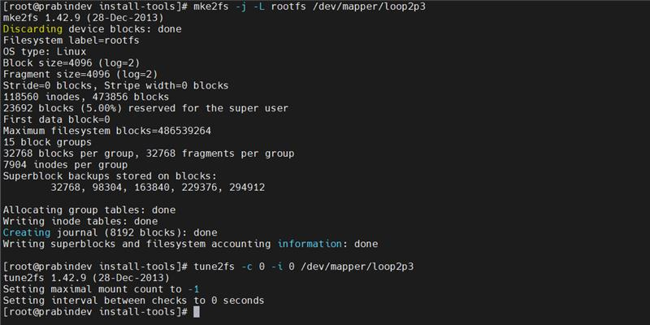
23) mount -t ext3 /dev/mapper/loop2p1 /mnt/loop2p1
24) mount -t ext3 /dev/mapper/loop2p1 /mnt/loop2p1
25) mount -t ext3 /dev/mapper/loop2p1 /mnt/loop2p1
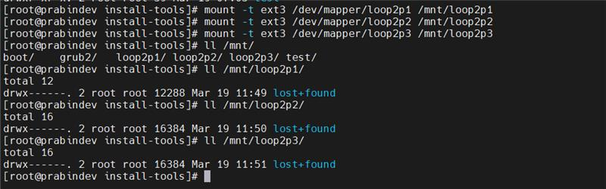
26) tar zxvf /tmp/monolith/rootfs.tgz -C /mnt/loop2p2
27) chown -Rh 0:0 /mnt/loop2p2/* /mnt/loop2p2.profile
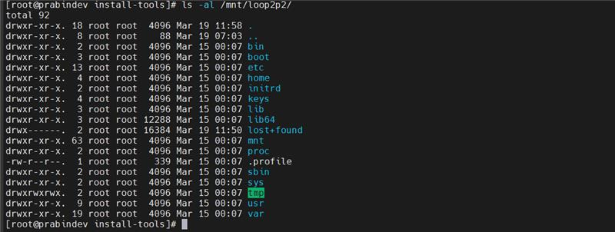
28) echo sda2 > /mnt/loo2p2/var/brix/toot-device
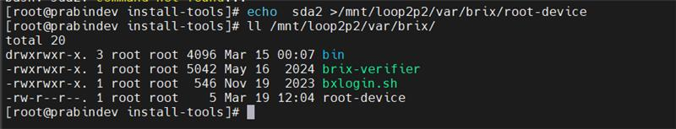
29) . /mnt/loop2p2/boot/install-tools/setup-env.sh
30) /mnt/loop2p2/boot/install-tools/exec-post-setup.sh no 3.18.12 nv40b bvm x86_64 /mnt/loop2p2 sda sda2 no
31) tar zxvf /tmp/monolith/rootfs.tgz -C /mnt/loop2p3
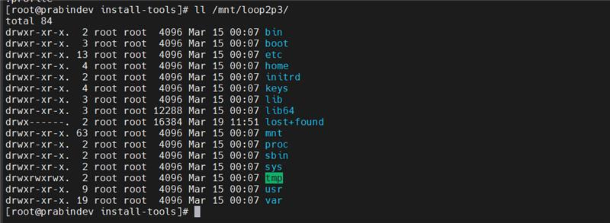
32) chown -Rh 0:0 /mnt/loop2p3/* /mnt/loop2p3/.profile
33) echo sda3 >/mnt/loop2p3/var/brix/root-device
34) /mnt/loop2p2/not/install-tools/exec-post-setup.sh no 3.18.12 nv40b bvm x86_64 /mnt/loop2p3 sda sda3 no
28) mkdir -p /mnt/loop2p1/boot/grub
29) cp /mnt/loop2p1/boot/grub/grub.cfg /mnt/loop2p1/boot/grub/.grub.cfg
30) ln -s /mnt/loop2p1/boot/grub /mnt/loop2p1/boot/grub2
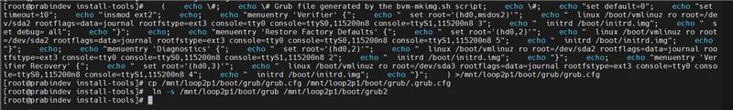
31) grub2-install –boot-directory=/mnt/loop2p1/boot /dev/lop2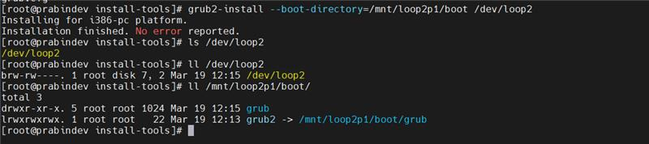
32) mkdir -p /mnt/loop2p1/brix/conf
33) cp /root/software/swv/platfoem/atomic-dog/image/lin-nv40b-x86_64-r/710011644928.vkr /tmp/info.vkr
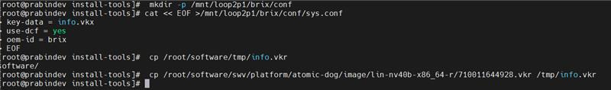
33) /root/software/exports/lin-vfr-x86_64-r/encrypt-vkr -o /tmp /tmp/info.vkr
34) cp /tmp/info.vkx /mnt/loop2p1/brix/conf/info.vkx
35) touch monolith.vmdk
36) sync
37) qemu-img convert -f raw -O vmdk /tmp/monolith.img monolith.vmdk